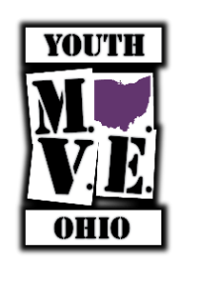**YouthMOVE Ohio**

**Youth Advisory Council Application**

**Contact Information**:

Name: ______ Age: _______

Address: ______

Phone: E-mail: ______ (If you don’t have a phone list a contact person/agency and their phone)

**Other:**  (Optional check all that apply)

* White/Caucasian
* Black/African American
* Native American
* Asian Native
* Hawaiian/Pacific Island
* Hispanic
* Other________

**Optional: Preferred Pronouns:** He/Him She/Her They/Them

**Lived Experience:** Please check any of the following that applying **if you are comfortable**. This section is optional and please know that all answers will remain anonymous and confidential. This is only to help identify your areas of expertise.

* Foster Care
* Juvenile Justice
* Mental Health
* Hospitalized due to Mental Illness issues
* Substance Use Disorder (Drug or Alcohol)
* Transitional
* Lived in a group home
* Had an IEP or received Special Education Services
* Attached to family supports
* Unaccompanied or unattached to family
* Homeless
* LGBTQ
* Physical Disability

|  |  |  |  |
| --- | --- | --- | --- |
| **Leadership Interest:** Please check areas of interest or skills | | | |
| Social Media |  | Community Service |  |
| Planning Youth Projects and events |  | Speaking at events or meetings |  |
| Awareness Campaigns |  | Using my opinions to help others |  |
| Helping others |  | Leadership Opportunities |  |

**Short Answer Questions: (can be a few words or sentence or two)**

What is your biggest concern or issue affecting your peers?

What is an issue you care about in your community (poverty, hunger, bullying, stigma… or whatever)

Anything else?